
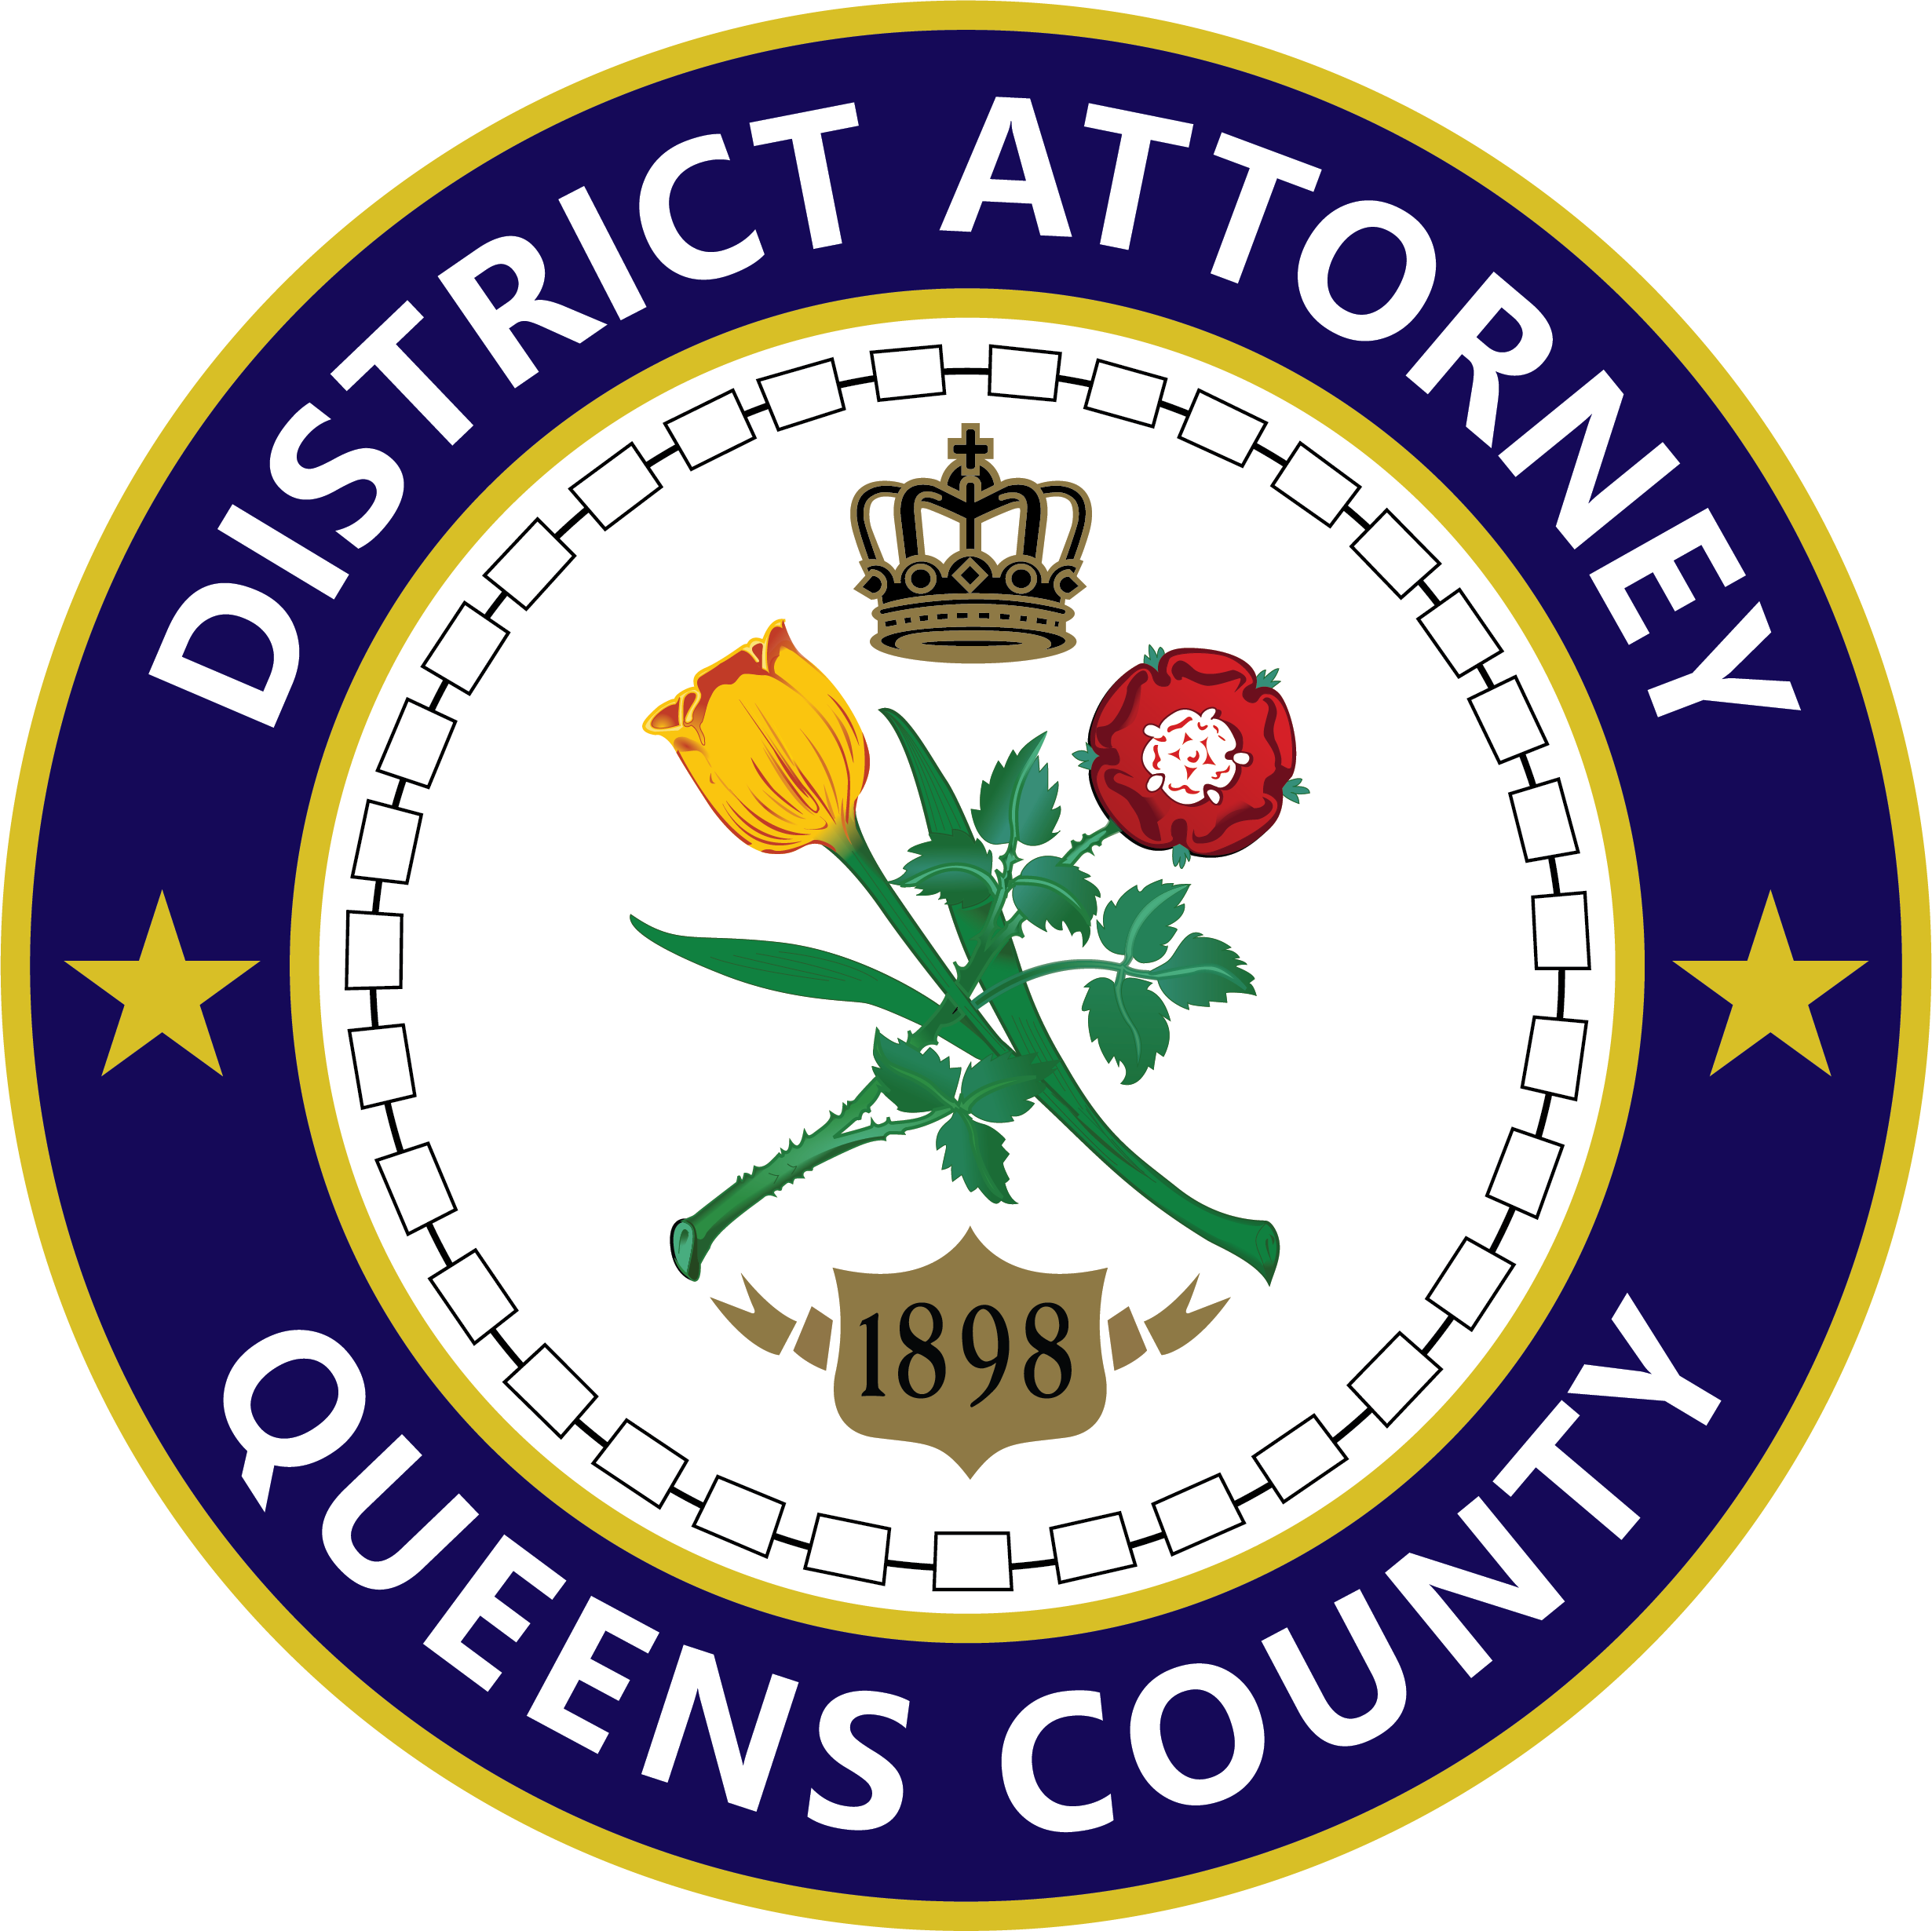
Release# 152-2026
X@QueensDAKatz
Queens County District Attorney
125-01 QUEENS BOULEVARD
KEW GARDENS, NEW YORK 11415-1568

Melinda Katz
District Attorney
Lochan: Frank Rothman
Young: Ken Finkelman
718.286.6000
www.queensda.org

FOR IMMEDIATE RELEASE CONTACT: PRESS OFFICE (718) 286-6315 FRIDAY, OCTOBER 9, 2026 QDACommunications@queensda.org

TWO EDGEMERE MEN PLEAD GUILTY TO MANSLAUGHTER FOR SHOOTING DEATH OF 10-YEAR-OLD BOY IN DISPUTE OVER SHARED DRIVEWAY
Defendants Ashram Lochan and Jovan Young Expected to be Sentenced to 19 Years and 24 Years in Prison, Respectively, Later this Month
Queens District Attorney Melinda Katz announced today that Ashram Lochan and Jovan Young have pleaded guilty to manslaughter in the first degree for the 2021 shooting that caused the death of a 10-year-old boy and seriously injured another man. The incident was sparked by an earlier dispute over a shared driveway.
District Attorney Katz said: “This incredibly senseless killing devastated the entire city. A 10-year-old boy, just days from his next birthday, was shot and killed as he met his cousin at the door. Defendant Jovan Young, acting at the behest of Ashram Lochan, fired multiple rounds into the home because of a dispute over a shared driveway. Tragically, Justin Wallace lost his life, while the child’s cousin was struck by multiple bullets and survived. We hope this plea will help Justin’s family as they continue to mourn his loss.”
Lochan, 32, of Edgemere, pleaded guilty last month to manslaughter in the first degree before Queens Supreme Court Justice Ushir Pandit-Durant who indicated that she would sentence him to 19 years in prison to be followed by five years post-release supervision on October 16.
Young, 34, of Edgemere, pleaded guilty on October 6 to manslaughter in the first degree before Queens Supreme Court Justice Michael Yavinsky who indicated that he would sentence Young to 24 years in prison to be followed by five years post-release supervision on October 23.
Both defendants pleaded guilty in satisfaction of indictments that variously charged them with murder in the second degree, attempted murder in the second degree, assault in the second degree, criminal possession of a weapon in the second degree and tampering with physical evidence.
According to the indictment and investigation, on June 5, 2021, Lochan was involved in a dispute with victim, Kyle Forrester, 29, who lived next door on Beach 45th Street, over their shared driveway. Later that evening, at approximately 9:30 p.m., Young, acting at Lochan’s direction, fired a pistol multiple times into Forrester’s residence and in his direction as he entered his front door.
Forrester was struck multiple times in the back, once in the hand and once in the neck and was immediately transported to a local hospital. Justin Wallace, 10, who was inside, near the door, was struck once in the chest. He was immediately transported to a local hospital where he later died from the gunshot wound.
Assistant District Attorney Jonathan Selkowe, Deputy Bureau Chief of the District Attorney’s Homicide Bureau, is prosecuting the case under the supervision of Assistant District Attorney John Kosinski, Bureau Chief, and under the overall supervision of Chief Assistant District Attorney Shawn Clark.

#
Note to Editors: Archived press releases are available at www.queensda.org.

‌ ‌ ‌

